[**Aljori Al Kuwari**](mailto:aljorik@andrew.cmu.edu) **Alina Barmagambetova**

**Aljorik, Abarmaga**

**Costco**

**COST**

*Evaluating Financial Health of a Company using Widely Used Accounting Ratios*

*You are required to submit your own work but encouraged to seek help from Course Instructor and your CAs. In addition, feel free to discuss the questions with your classmates and exchange ideas. Projects that do not follow the instructions below and late submissions will not be accepted and will receive a grade of zero. No exceptions.*

**Please sign the following academic integrity statement and include this page with your project (second page after Cover).**

**Statement of Academic Integrity:**

I have neither given nor received unauthorized aid on this project, nor have I concealed any violations of the university’s Academic Integrity policies.

Signature:  

Conclusions

1. What is your company’s main line of business and the primary industry it operates in? (Maximum 4 sentences)

Costco's main line of business is operating a membership-based warehouse and online platform where customers can purchase a range of products in bulk at a discounted price. The primary industry Costco operates in is the domestic warehouse club industry. The company focuses on providing exclusive offers and discounts to its members, who pay an annual membership fee to access these benefits. Costco's business model emphasizes providing value and savings to its members through a combination of low prices and high quality goods.

2. Based on your time series and cross-sectional ratio analysis, what can you say about the overall financial health of your company? Would you invest in your subject company and why? Your answer should be as complete as possible by linking all pieces together.

Based on a time series and cross-sectional ratio analysis of Costco's financial performance from 2021 through 2023, the company's overall financial condition looks stable and promising. The stock price trend, which follows the movement of the S&P 500 index, indicates the company's solid position in the market. Despite market fluctuations and slight declines in some ratios between 2022 and 2023, Costco appears to be stable compared to other companies.

Costco has maintained a relatively lower net profit margin which in this case can serve as an advantage, ensuring long-term success. The company focuses on maintaining a loyal customer base and its customer retention rate is over 90%, further strengthening its position in the market.

While Costco's price to earnings (P/E) ratio may be higher than some of its retail peers, this can be justified by its stable performance, loyal customer base, and the basic nature of its offerings. As a provider of basic necessities, especially in the grocery sector, Costco enjoys steady demand, making it a relatively safe investment option even during an economic downturn.

Costco has an overall better efficiency ratio compared to its competitors in similar industries which showcases that Costco is more profitable. We can see that in Costco Number of Days Sales Inventory from 2021 through 2023 ratios are 28.29, 29.40, and 29.67 while the industry median is 90.58, that means Costco is able to sell their inventory in 3 times less the days it

takes for the industry median to sell. Its ratio is pretty stable, not showcasing any spikes which shows us that they would be better-off in the long-run.

Given Costco's solid financial performance, loyal customer base, and growth potential, I agree with the view that Costco is a smart investment choice.

3. Is the stock price performance of your subject company consistent with their Financial Statement based ratios you calculated? (Hint: You should plot the daily stock price of your company in the past 3 years and see if it matches with the trend in various relevant ratios and its relative performance compared to the peers: i.e. industry mean and median in the last year). Make sure start and end time of your graph matches with Financial Statements. On the same graph, also plot SP500 Index. Comment. (Hint: you can use Bloomberg for this plot)

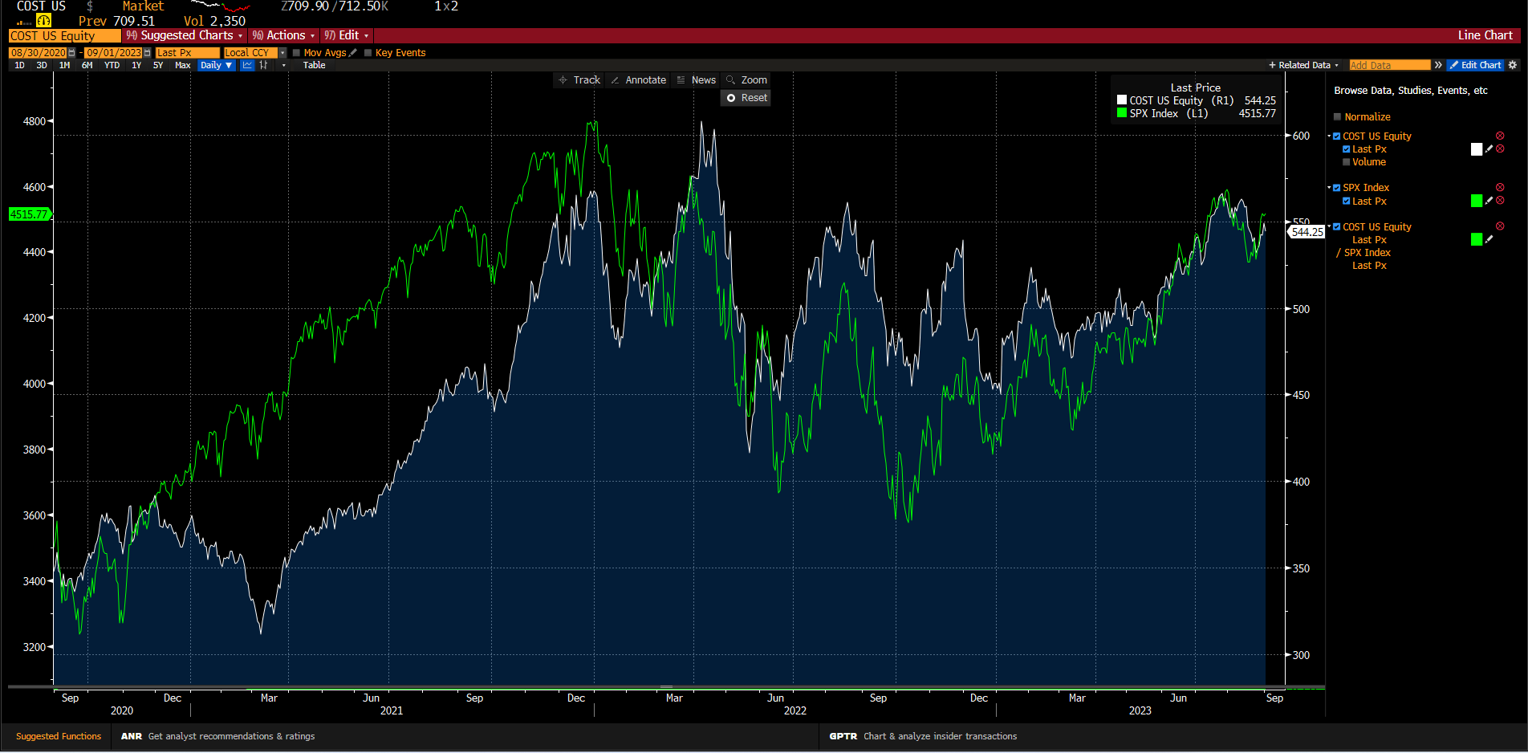

Costco’s stock price is mostly consistent with the S&P 500 metrics which indicates a good standing of the company and is favorable to investors. Similarly, most of the ratios indicate a good position compared to peers’ companies and did not significantly deviate across the given timespan.

The stock’s price was improving in 2021 as the financial market was recovering from the pandemic and since the company is part of the retail industry, it underwent an increase of the share’s price once the lockdown policies were eased. Specifically, as the company is designed for small and medium sized businesses, once the pandemic restrictions were eliminated and business started opening again their stocks increased. We can see in 3 out of 4 profitability ratios the number had an increase from the year 2021 to 2022. The examples are Return on Equity which increased by approximately 3%, Return on Assets that went up by 1% and Net profit margin that had a growth of 0,01%. This can also be reflected in Costco's share price as it went up in the first half of the time frame.

Likewise, it dropped in the year 2022 following the S&P 500 due to the crash of financial markets and fluctuated until it came to the same position as at the beginning of 2022. In ratios we can see that from the year 2022 to 2023 it underwent a slight decrease in the numbers: ROE went down by 2,5% and ROA decreased by 0,02%.

Nevertheless, the company stays consistent with the market which is reflected in minor changes in ratio numbers and better performance in the retail industry.

4. What’s the Consensus Analyst Recommendation on Bloomberg (i.e. buy, hold, sell)? What’s 12-month target price? Do you agree the Analyst recommendations? Why or why not? Hint: you can use ANR function on Bloomberg to get this information. Please include a screenshot of the relevant section of Bloomberg screen with your answer.

According to the ANR as of 09/03/23, 64,3% of analysts (27 out of 42) recommend buying Costco’s stocks and 35.7% (15 out of 42) suggested holding them. Also, we can see that 0% of all analysts recommended selling them. These numbers are a positive indicator for the company as it shows a possible good future performance. In addition to that, the 12-month target price is 577.41 which is higher for 6,1% compared to the last price of 544,25. Based on the previous analysis and the ratios I agree with the ANR. I believe that the company's share will continue to grow and possibly outperform or at least stay consistent with the market’s numbers. They have a growth potential as well as a good and deserved reputation. Also, I feel this company is a safe option as it has a loyal customer base due to the membership policies and a high member retention rate which is always over 90%.

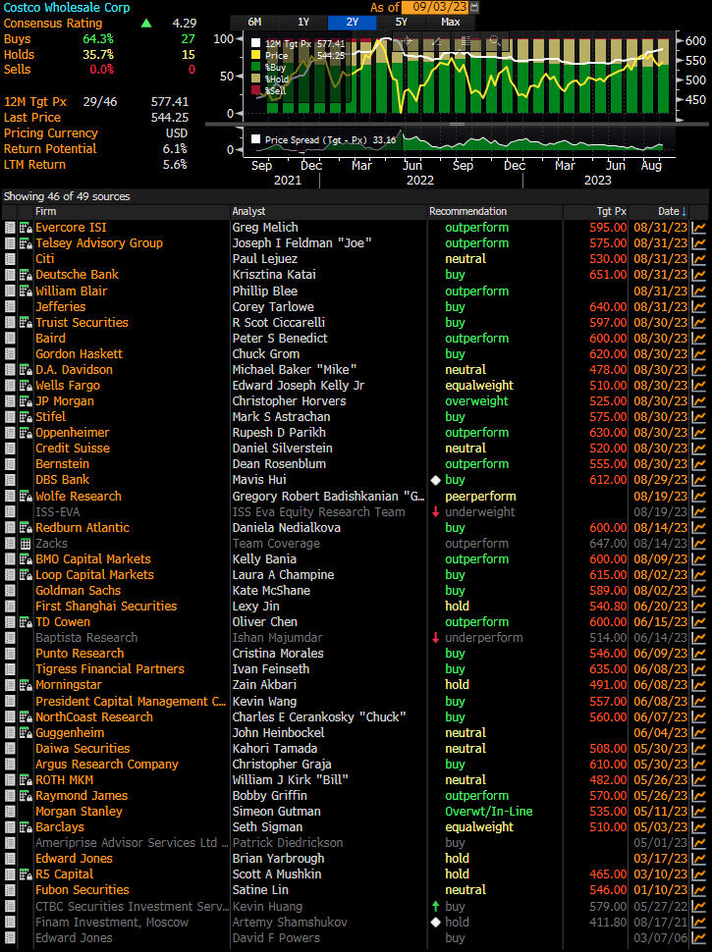

5. When you compare your company’s performance relative to the industry it is in, would you rather use Industry Mean or Industry Median? Why or why not?

When comparing our company's performance to the industry in which it operates, I would prefer to use the industry median rather than the mean. This is because the industry median provides a more representative measure of an average performance especially when there are extreme numbers (outliers) like BIG LOTS INC and DOLLARAMA INC. These outliers can skew the distribution and misrepresent the mean so the median is a more reliable measure for estimating the typical performance of companies in an industry.